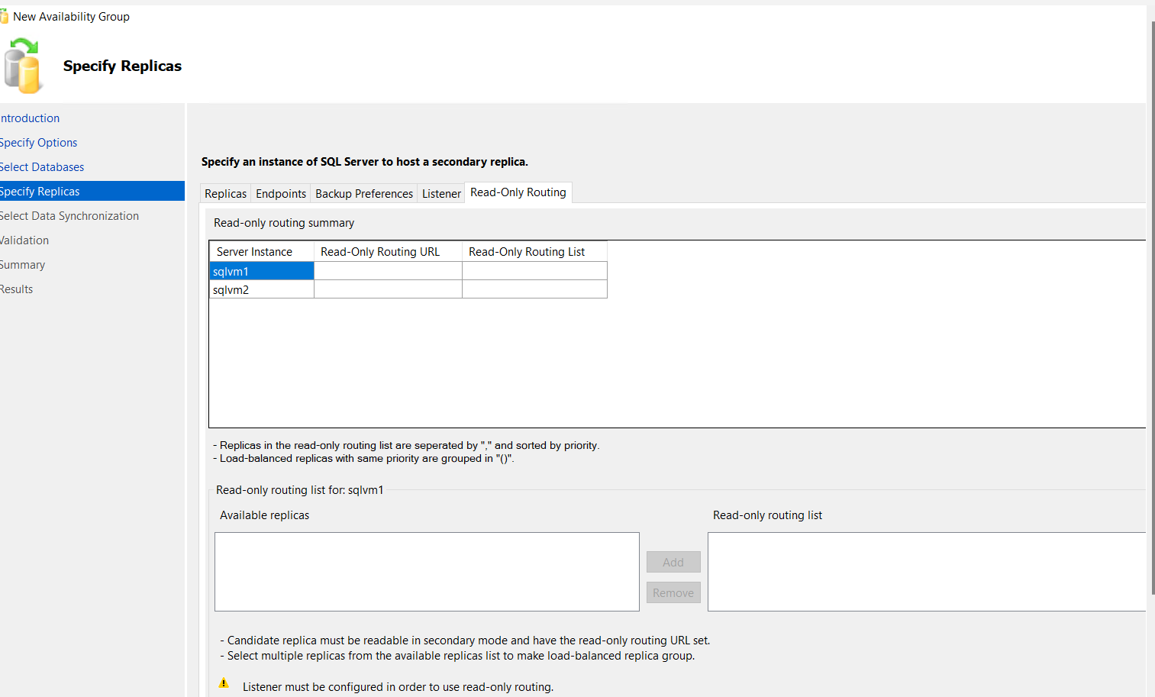
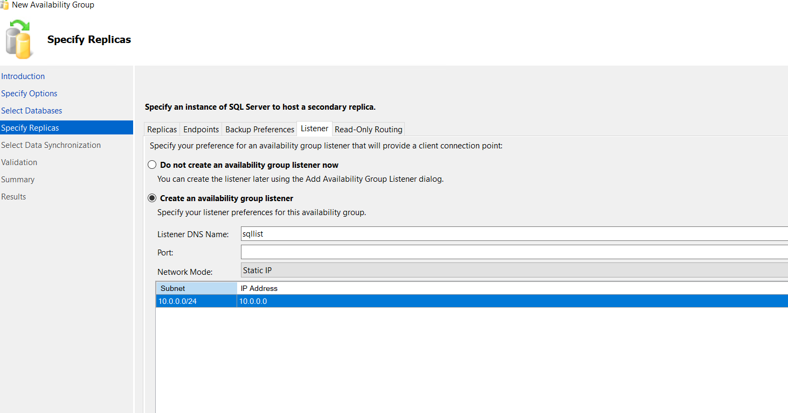
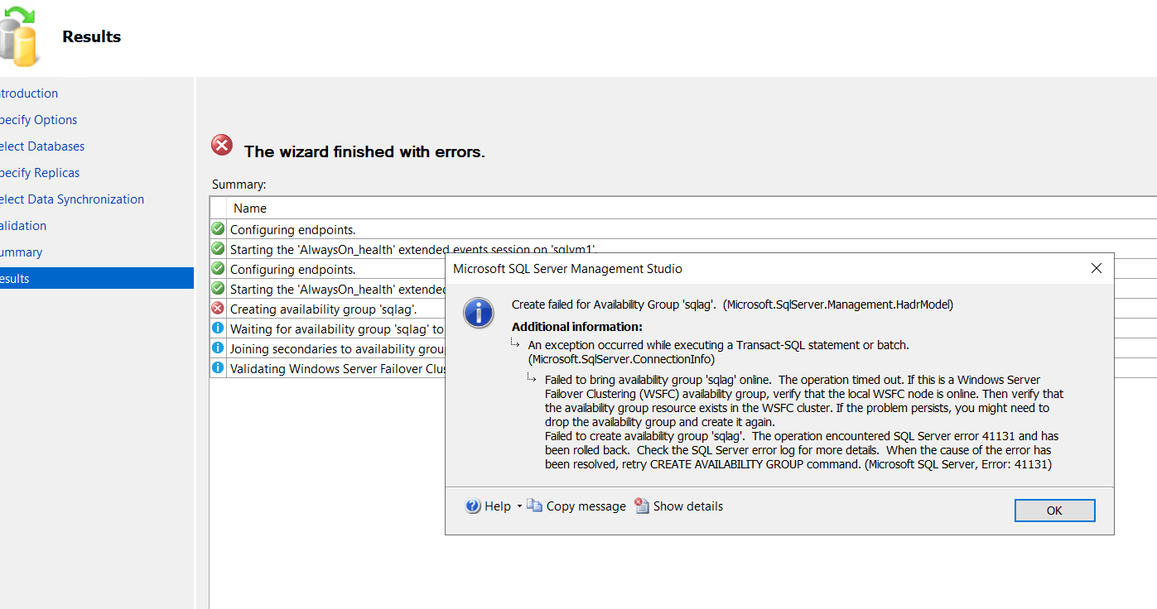
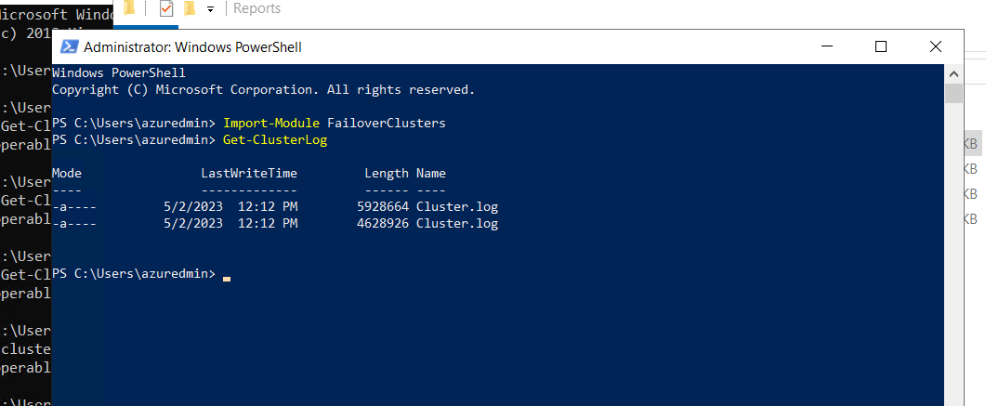

Solution to the above problem:

GRANT ALTER ANY AVAILABILITY GROUP TO [NT AUTHORITY\SYSTEM];
GRANT CONNECT SQL TO [NT AUTHORITY\SYSTEM];
GRANT VIEW SERVER STATE TO [NT AUTHORITY\SYSTEM];

Since NT AUTHORITY\SYSTEM account will act as the computer account on the network, and the SQL Server service account, no matter the domain account or built-in account, which acts as the computer account, must be added as a user on the secondary replica instance.

Second Problem is TEST database was not able to join the AG group on secondary replica
To check the endpoint status

select r.replica_server_name, r.endpoint_url,
rs.connected_state_desc, rs.last_connect_error_description,
rs.last_connect_error_number, rs.last_connect_error_timestamp
from sys.dm_hadr_availability_replica_states rs join sys.availability_replicas r
on rs.replica_id=r.replica_id
where rs.is_local=1

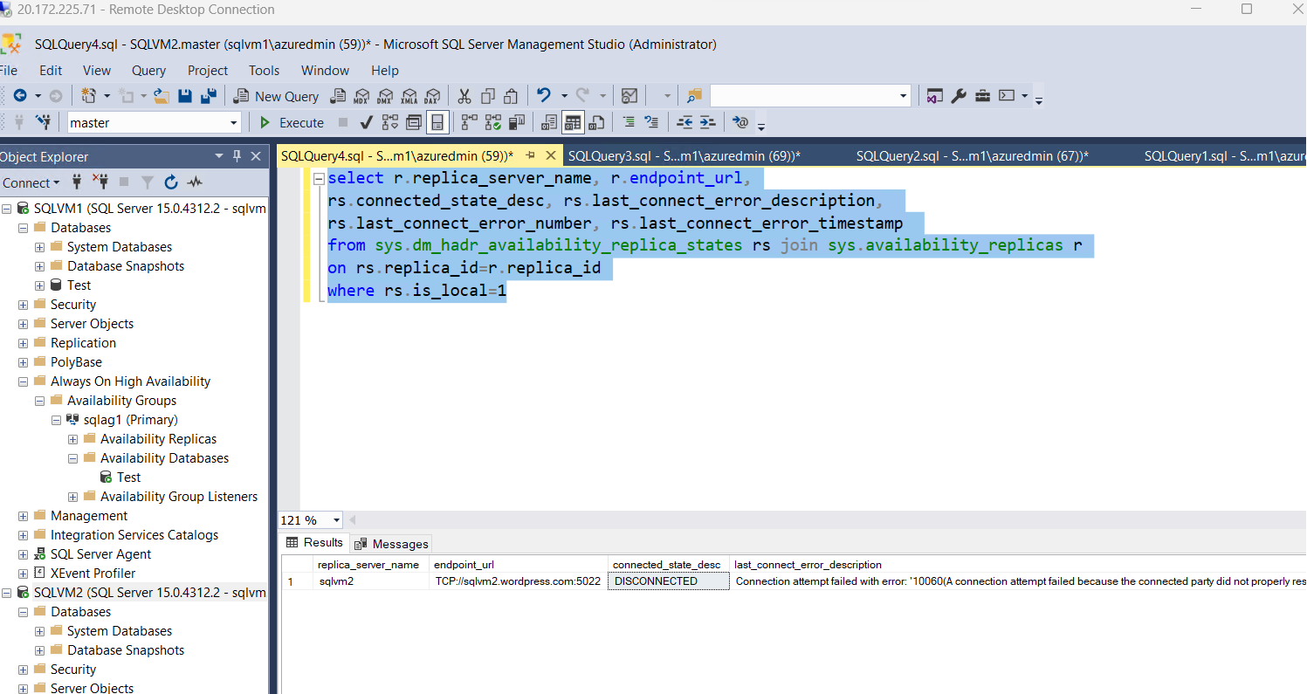

Create the rule in the FIREWALL

Also give connect permission to endpoints on both the servers
GRANT CONNECT ON ENDPOINT::Hadr_endpoint TO [NT Service\MSSQLSERVER]
GO

The account must be a domain account and it should be sysadmin permissions, without which both the services will not be able to talk to each other.
Command to add the IP resource to the underlying cluster
Add-ClusterResource -Name NewIP -ResourceType "IP address" -Group "Cluster Group"

